952 DC JACKPOT PRIZE POOL AND PRIZE STRUCTURE

952.1 DC JACKPOT tickets will be drawn from a pool of two hundred forty thousand (240,000) tickets for each of the three price points: two dollars ($2); five dollars ($5); or ten dollars ($10) per ticket.

Two Dollar ($2) DC JACKPOT Fast Play Game

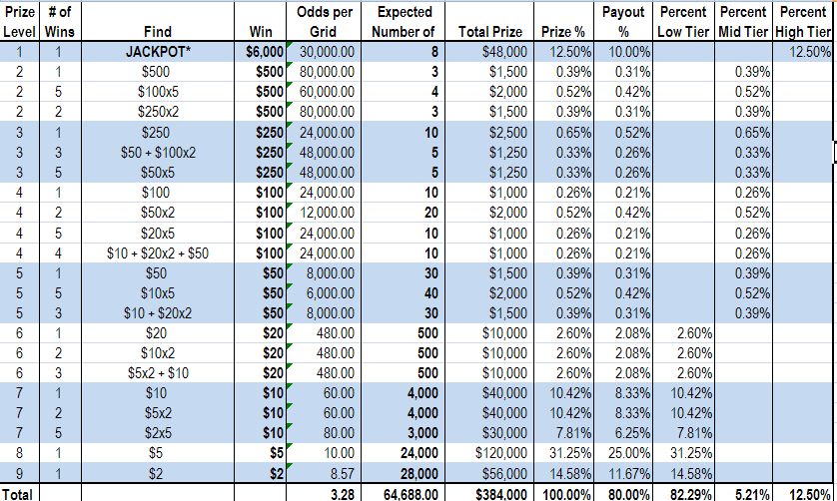
The prize structure above shows the estimated average progressive jackpot amount.

Five Dollar ($5) DC JACKPOT Fast Play Game

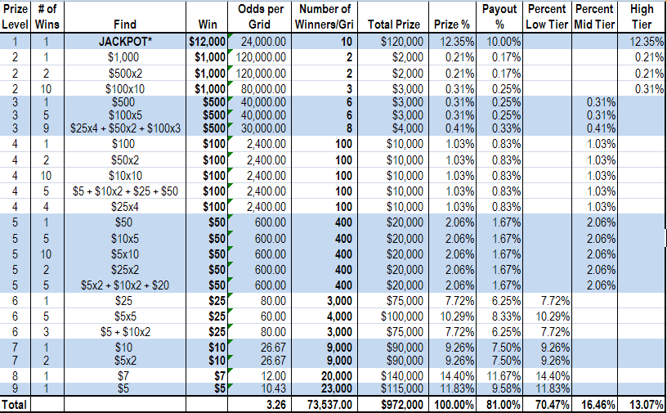
The prize structure above shows the estimated average progressive jackpot amount.

Ten Dollar ($10) DC JACKPOT Fast Play Game

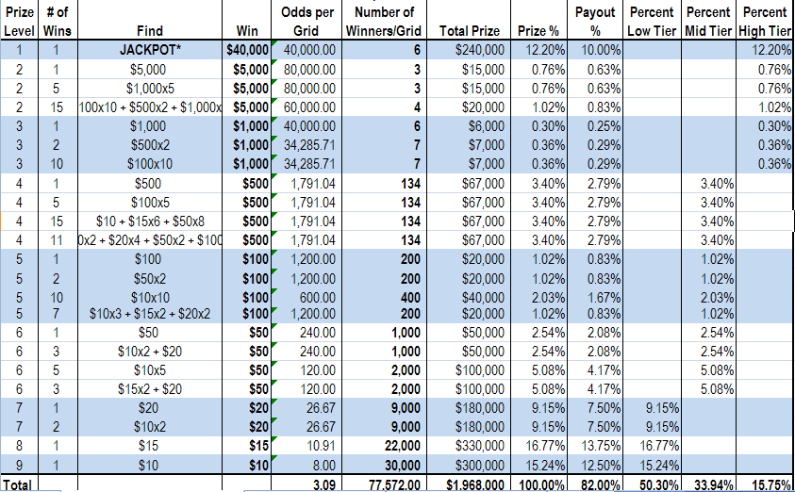
The prize structure above shows the estimated average progressive jackpot amount.

SOURCE: Notice of Final Rulemaking published at 58 DCR 2677, 2680 (March 25, 2011); as amended by Notice by Final Rulemaking published at 59 DCR 3146, 3148 (April 20, 2012); as amended by Final Rulemaking published at 59 DCR 9201, 9202 (August 3, 2012).

